**Quran App**

## Admin Dashboard

1). Admin can Create/update/delete the Groups.   
The Group Form will have Following Fields

|  |  |
| --- | --- |
| Fields Name | Type |
| ID | Int (Auto Increment) |
| Name | Single line Text |

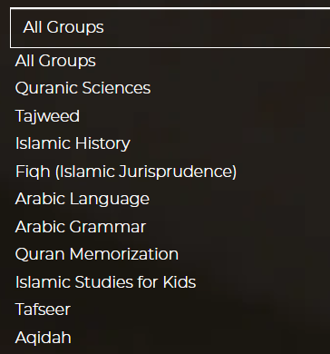  
E.G

2). Only admin can Create/update/delete the tutors/teacher

The Tutor Form will have following Fields

|  |  |
| --- | --- |
| Fields Name | Type |
| ID | Int (Auto Increment) |
| Name | Single line Text |
| Contact | Int |
| Email | Single Line Text |
| Password | Single lineText |
| Confirm password | Single Line Text |
| Degree | Single line Text |
| City | Drop down |
| Country | Dropdown |
| Groups | Multiselection - Dropdown (Group will be filled by another form) |
| About | Multiline Text |
| Work Experience | Multiline Text |
|  |  |

3). Admin can Create/update/Delete courses.

The courses Form will have following Fields

|  |  |
| --- | --- |
| Fields Name | Type |
| ID | Int (Auto Increment) |
| Name | Single line Text |
| Tagline | Single line text |
| Thumbnail | Picture |
| Description | Multiline text |
| Total Number of Classes | Int |
| Number of classes per week | Int |
| Course Price | Int |

4). Admin can see the list of Student and can see their progress

5). Admin have rights to see their tutors list at once.

6). Admin can see their payment received amount and which student pays how much amount according to date wise

7) Admin will see the enrolled courses list of student.. and will manually assigned tutor to it.

8). Each and every process of the web app will include email

## Student Dashboard

1). Student will be sign up from the website

The Student Form will have following Fields

|  |  |
| --- | --- |
| Fields Name | Type |
| ID | Int (Auto Increment) |
| Name | Single line Text |
| Father Name | Single Line Text |
| Contact | Int |
| Email | Single Line Text |
| Password | Single lineText |
| Confirm password | Single Line Text |
| City | Single line Text |
| Country | Single line Text |

2). Student can see their enrolled courses,

3). Student can see the remaining classes of courses

4). Student can see the progress of courses

5). Student can see the paid amount of their courses

6). Student can ask question from their tutor

7). Student can see their assigned tutor

8). Student can give Feedback after the completion of whole course

9). Each and every process of the web app will include email

## Tutor Dashboard

1). Tutor can see their assigned students and their courses

2). Tutor can share their zoom or skype id to student.

3). Tutor can give feedback after each class in text form.

4). Tutor can manage their student and their asked questions

5). Each and every process of the web app will include email

## Website

Website will have landing page/home page, Courses page, About Page, Testimonial Page, How this platform works, Faqs, Terms of Services, Contact/Support Page.

There will be Paypal integration in this system,